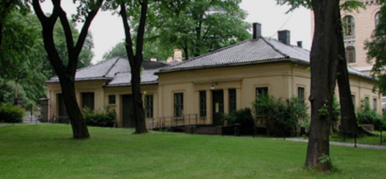
Annual meeting Working Group on Prolamin Analysis and Toxicity 23-24 October 2026

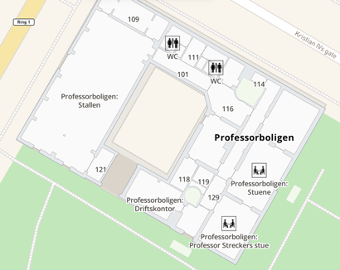
Venue: Oslo Professorboligen UiO
Number of attendees: 50+

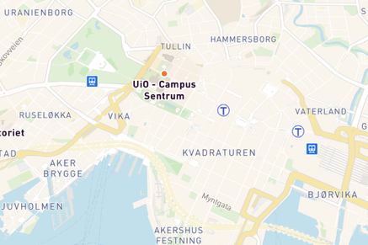
Thursday, 22nd October, 2025

Arrival of Prolamin Working Group and all participants.
Informal get-together with dinner (included in registration)

Friday, 23rd October, 2025

09.00 Opening of the meeting Carmen Gianfrani
09.15-12:15 Symposium on new food labelling and food allergy etc

09:15-09:45 Kang Zhou: FAO/WHO recent updates
09:45-10:15 Paul Turner, Imperial College: "Coeliac disease and food allergy: a synergistic approach"
10:15-10:45 Break
10:45-11:15 Carlo Catassi: On the response to gluten
11:15-11:45 Thomas Weiss: R5 ELISA for food analysis
11:45-12:15 Floris Overveld, the patient perspective
12:15-13:15 Lunch

13:15-15:00 The Immunosafe project – what did we find?
13:15 Katharina Scherf Introduction by project leader
13:20 Ludvig Sollid/Julie Hegglund antibodies to barley
13:35 Katharina Scherf Proteomic analysis of malted barley and gluten-free barley beer
13:50 Carmen Gianfrani T cell responses to barley peptides
14:05 Nancy Odden clinical response to barley and malted barley
14:20 Detlef Schuppan TBD
14:30-15:00 Break
15:00-17:00 Clinical and analytical research reports Troncone, Chirdo, Catassi, Schuppan, Jonkers, Gianfrani, Lundin, Masci, Scherf, Smulders, guests
17:30-18:30 Business meeting of Prolamin Working group (by invitation only)
- The new gliadin standard incl business plan?
- Statutes and framework?
- Economy and

19:30 Joint Dinner for all participants, location TBD

Saturday, 24th October, 2025

09.00-10:30 Clinical and analytical research reports Troncone, Chirdo, Catassi, Schuppan, Jonkers, Gianfrani, Lundin, Masci, Scherf, Smulders, guests
Oral presentations
Food Technology Companies

10:30-10:45 Break

10:45-12:00 Clinical and analytical research reports Troncone, Chirdo, Catassi, Schuppan, Jonkers, Gianfrani, Lundin, Masci, Scherf, Smulders, guests
Oral presentations
Food Technology Companies

12:00-13:00 Discussion of current developments concerning
- Gluten analysis, clinical and legal aspects
- Statements by participating organisations,
representatives from industry, and guests
- Action plan 2026/27 of the Prolamin Working Group

13.00 Lunch box and farewell

Accomodation: Central Oslo
Congress organization: CIC event congress https://cic.no/

